Build Plan

For Red Turf Project

Version 1.4

Tanvi IT Solutions Inc

4211 Pleasant Valley Rd,

Suite 230

Chantilly, VA- 20151

**Revision History**

|  |  |  |  |  |  |
| --- | --- | --- | --- | --- | --- |
| Version (x.y) | Date of Revision | Description of Change | Reason for Change | Affected Sections | Approved By |
| 1.1 | 1/10/18 | Baseline Version |  |  | Nagoor Inaganti |
| 1.2 | 8/10/18 | Addition of Search, Dashboard Module | Requirement Development | Build Plan | Nagoor Inaganti |
| 1.3 | 15/10/18 | Addition of modules | Updated Requirements | Build Plan | Nagoor Inaganti |
| 1.4 | 5/11/18 | Final Sequence of Integration | Updated along with the build plan | Integration Approach | Nagoor Inaganti |

**Approval History**

|  |  |  |  |
| --- | --- | --- | --- |
| Version (x.y) | Prepared By | Reviewed By/Date | Approved By/Date |
| 1.1 | Vijaya Somarepetta | Monalisha Mishra  1/10/18 | Nagoor Inaganti  1/10/18 |
| 1.2 | Vijaya Somarepetta | Monalisha Mishra  8/10/18 | Nagoor Inaganti  8/10/18 |
| 1.3 | Vijaya Somarepetta | Monalisha Mishra  15/10/18 | Nagoor Inaganti  15/10/18 |
| 1.4 | Vijaya Somarepetta | Monalisha Mishra  5/11/18 | Nagoor Inaganti  5/11/18 |

Table of Contents

1 Objectives and Scope 3

2 Roles and Responsibilities 4

3 Integration Approach 4

4 Builds 4

4.1 Build 1 4

4.2 Build 2 4

# Objectives and Scope

This document defines the sequence in which the application components are integrated into the various application builds. The Build Plan is scoped by the functionality delivered within a development iteration or release. Build Plan deliverable is to clearly specify the components belong in each build, accounting for any build/compilation dependencies between the components. Programmers and the Testing team will use this document. Programmers use the Build Plan to prioritize the coding and delivery of the components to meet the integration order. The test lead and testers use this deliverable to define the tests needed for each application build. The Build Plan follows the agile methodology.

# Roles and Responsibilities

|  |  |
| --- | --- |
| Role | Responsibilities |
| Project Management | Project financials  Status reporting  Project governance  Identification of missing roles and/or resources  Business stakeholder communication  Risk communication and management  Project planning  Change management |
| Configuration Management | Responsible for the process design  Manage any new requirements or changes to the Process  Directs and schedules the training of new CI owners and CI coordinators  Responsible for the execution of the process controls, ensuring that staff comply with process and data standards. |
| Requirement Management & Development | Identify stakeholders  Gather/elicit requirements  Analyze requirements  Specify/document requirements  Baseline requirement groups (verify, validate, and prioritize requirements- i.e.: agree and sign-off on requirements)  Communicate requirements  Monitor/track requirements  Manage and control changes to requirements  Report requirements compliance |
| Architecture and Design | Identifying business requirements and requirements of the stakeholders on the project  Designing the entire system based on the received requirements  Choosing the system architecture and each individual component of this system at a high level  Choosing the technologies for the implementation of each component and connections between the components  Architectural review  Code-review  Writing project documentation and its support  Creating unified development standards in the company  Controlling the architecture during the next iteration of the system release |
| Coding | Modifying software to fix errors, improve its performance, or upgrade interfaces.  Directing software programming and documentation development.  Working with customers or departments on technical issues including software system design and maintenance.  Consulting with engineering staff to evaluate software-hardware interfaces and develop specifications and performance requirements.  Designing and developing software systems using scientific analysis and mathematical models to predict and measure outcomes and design consequences.  Preparing reports on programming project specifications, activities, or status.  Conferring with project managers to obtain information on limitations or capabilities. |
| Testing and Validation | Directing system testing and validation procedures.  Monitoring and testing equipment  Analyzing and documenting test results  Preparing compliance reports  Directing validation activities  Resolving testing problems  Adjusting or improving equipment and processes  Creating databases to track validation activities  Interpreting customer requirements  Developing validation schedules  Conducting training and overseeing the work of Validation technicians  Maintaining instrumentation and equipment  Keeping up to date on industry standards and regulations |
| Senior Management | Ensuring clarity around priorities and goals for the entire functional area  Approving requests for investment to a certain level of authority  Managing overall financial budgeting for function  Approving hiring and firing requests within group  Guiding the talent identification and development processes for a group or function  Working across functions with peers in other groups to ensure collaboration for shared goals  Interacting with senior management for reporting  Working with senior management and other peers for strategy development and execution planning  Communicating financial and goal results and key performance indicators to direct reports  Facilitating goal-level creation for the broader function and working with managers to ensure the goals cascade to all workers. |

# Integration Approach

The application components (e.g., source, binary, and executable code), data files, documentation files, online help files, etc. are integrated. The integration steps include the following:

* Integration Sequence: The various modules that include Search, Dashboard, Resident, Tasks, Lists, Mapping, Election Check-in module are integrated together.
* Compatibility of the module/ component: During the integration of the various modules the compatibility of the modules are validated.
* Criteria for integration: In order to deliver overarching functionality of campaign and constituent management.
* Specified components are assembled into build directories.
* Compile and link command files are created.
* Compiling and linking the components into executables.
* Initializing the databases.
* Migrating the executable, data, and test scripts to the environment.
* Executing the component, assembly, or integration test.

# Builds

Agile methodology is followed in the development of the Red Turf project. Throughout development, application components are collected and repeatedly compiled for testing purposes, to ensure a reliable final product. The following is the build process that has been used in the development of Red Turf.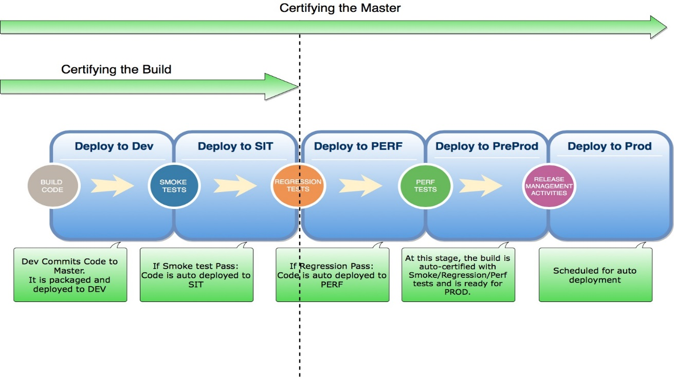

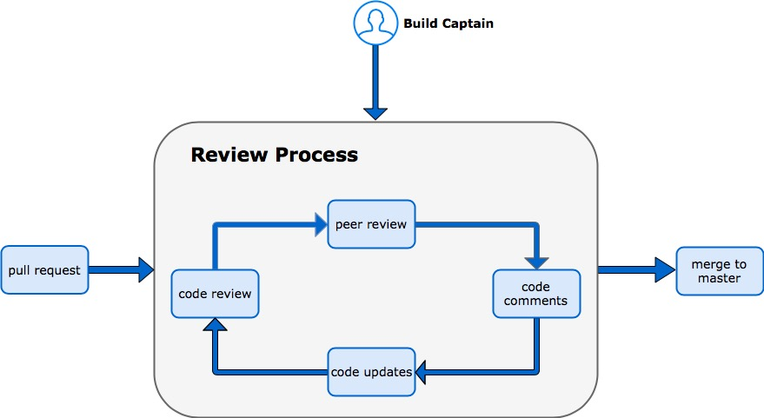

## Build 1

During Build 1 of the project, the Search module is built along with the in-built features that include:

Search by last name,

Search by last name, first name

Search by string

Search using special characters in the name.

## Build 2

During Build 2 of the project, the Dashboard module is built along with the in-built features that include:

Election Analysis

Charts

Notifications

Import file data

## Build 3

During Build 3 of the project, the Resident module is built along with the in-built features that include:

Add Voter

Add Resident

## Build 4

During Build 4 of the project, the Task module is built along with the in-built features that include:

All Tasks

My Tasks

## Build 5

During Build 5 of the project, the List module is built along with the in-built features that include:

Call List

Email List

Direct Mail

Walk List

## Build 6

During Build 6 of the project, the Mapping module is built using the US postal Services address database.

## Build 7

During Build 7 of the project, the Electronic Check-in module is built along with the in-built features of Election Check-in

Check-in Report

Election Users